

**La Consolacion College – Daet**

F. Pimentel Ave., Daet, Camarines Norte

S.Y 2022 - 2023

_____________________________________________________________________________________

**MIDTERM EXAM**

NAME: MICHAEL JAMES SORIA

COURSE: BSCS-2

* **LINEAR PROGRAMMING**
* In accurate answer Linear programming is a method of optimizing operations with constraints in mathematics. The primary goal of linear programming is to maximize or minimize numerical values. It is made up of linear functions that are constrained by constraints in the form of linear equations or inequalities. But not just in mathematics, you can also apply linear programming in real life, especially in your daily life, decision making, time management and etc.….

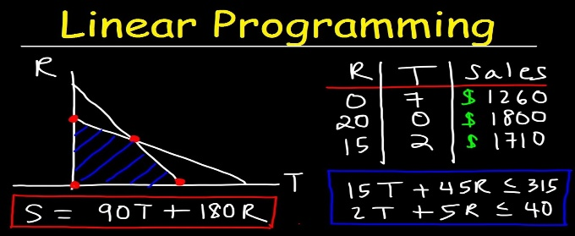

* **LINEAR ALGEBRA**
* a branch of mathematics concerned with mathematical structures closed by addition and scalar multiplication, including the theory of systems of linear equations, matrices, determinants, vector spaces, and linear transformations, linear algebra for me is more on time management, it will help you to decide which is more efficient for calculation of speed, distance and time.

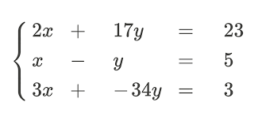

* **TRAVELING SALES MAN**
* A traveling salesman is a man whose job it is to sell products or services by traveling to various locations, typically within a specific region or assigned territory. A traveling salesman is also known as a traveling salesperson. A traveling saleswoman is the female equivalent. This is about what is alternative ways that you go for it, with a same destination, it will help you to decide what is more efficient ways going to your destinations with a less time, money or hassle.

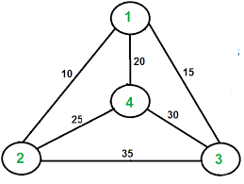

* **ALGORITHM COMPLEXITY**
* Algorithmic complexity is a measure of how long it would take an algorithm to complete given an n-dimensional input. If an algorithm must scale, the result should be computed within a finite and practical time bound, even for large values of n. As a result, as n approaches infinity, complexity is calculated asymptotically.

